**Schule Oberägeri**

**Projektwoche Robotik**

[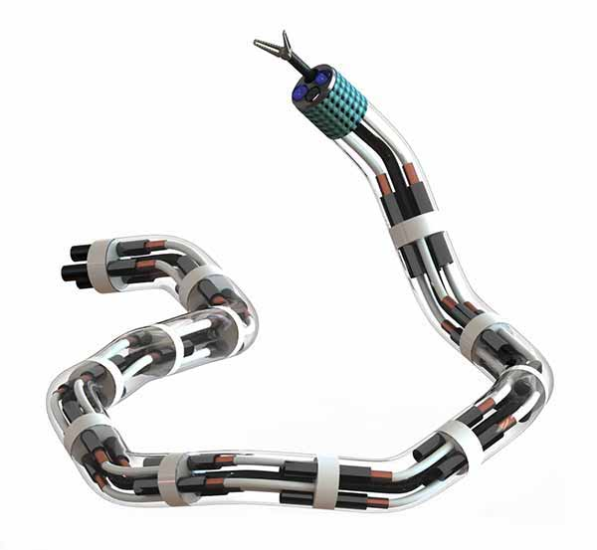](http://www.google.ch/url?sa=i&rct=j&q=&esrc=s&source=images&cd=&cad=rja&uact=8&ved=0ahUKEwin8ZGl_v7LAhWCiRoKHZBoDDEQjRwIBw&url=http%3A%2F%2Fucsdnews.ucsd.edu%2Ffeature%2Fuc_san_diego_launches_robotics_institute&bvm=bv.119028448,d.d2s&psig=AFQjCNGjH0gJqvC8JHDOfleIvFAvjrlP1Q&ust=1460202945908618)[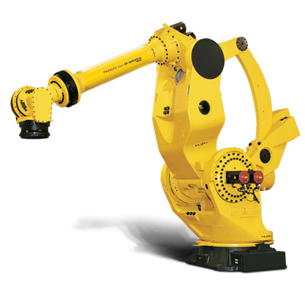](http://www.google.ch/url?sa=i&rct=j&q=&esrc=s&source=images&cd=&cad=rja&uact=8&ved=0ahUKEwj32tvN-f7LAhXBORoKHb6XACgQjRwIBw&url=http%3A%2F%2Fwww.fanuc.eu%2Fde%2Fde%2Froboter%2Froboterfilter-seite%2Fm-2000-serie%2Fm-2000ia-900l&bvm=bv.119028448,d.d2s&psig=AFQjCNGHcGAMfCGfRUjjE7jKm-OrMEYlCg&ust=1460201697492526)[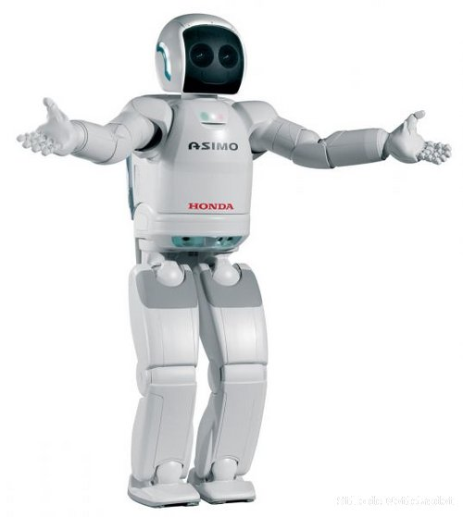](http://www.google.ch/url?sa=i&rct=j&q=&esrc=s&source=images&cd=&cad=rja&uact=8&ved=0ahUKEwiUhM2V-f7LAhXKHxoKHQl8AjgQjRwIBw&url=http%3A%2F%2Fenterpriseresilienceblog.typepad.com%2F.a%2F6a00d8341c4ebd53ef016305791212970d-popup&bvm=bv.119028448,d.d2s&psig=AFQjCNHtPXBJUZ3wkHmCtbiiySuHYVGO1g&ust=1460201643570406)

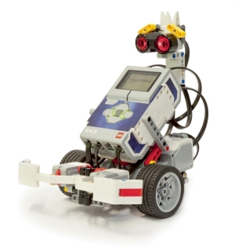

[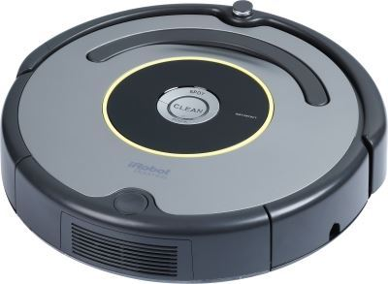](http://www.google.ch/url?sa=i&rct=j&q=&esrc=s&source=images&cd=&cad=rja&uact=8&ved=0ahUKEwifyYKh_P7LAhUFVhoKHYlGAAkQjRwIBw&url=http%3A%2F%2Fwww.landi.ch%2Fshop%2Fde%2Froboterstaubsauger-roomba-631&bvm=bv.119028448,d.d2s&psig=AFQjCNFDnSKQRleItHgONzCxIMh9CV-POg&ust=1460202460115047)[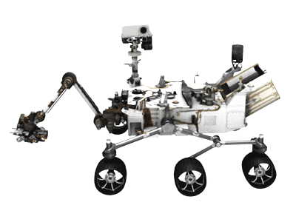](http://www.google.ch/url?sa=i&rct=j&q=&esrc=s&source=images&cd=&cad=rja&uact=8&ved=0ahUKEwjj1N_i-v7LAhVDqxoKHfKBA3cQjRwIBw&url=http%3A%2F%2Fwww.electronicproducts.com%2FSensors_and_Transducers%2FSensors%2FNASA_s_Curiosity_rover_lands_on_Mars_successfully.aspx&bvm=bv.119028448,d.d2s&psig=AFQjCNEpjI7MrdlekmGbuQlyGuePGGlj_w&ust=1460202043080731)

[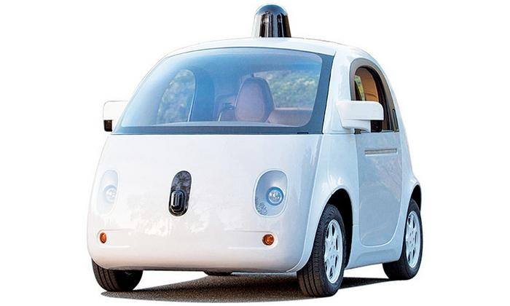](http://www.google.ch/url?sa=i&rct=j&q=&esrc=s&source=images&cd=&cad=rja&uact=8&ved=0ahUKEwioxayJ-_7LAhWMnBoKHQbDAJYQjRwIBw&url=http%3A%2F%2Fwww.autonews.com%2Farticle%2F20150103%2FOEM06%2F301059928%2Fwhere-is-googles-car-going%3F&bvm=bv.119028448,d.d2s&psig=AFQjCNFn_jxv9UY3Y3NAT19M_R0FFEaC3g&ust=1460202155003372)[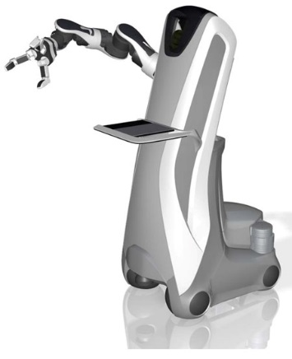](http://www.google.ch/url?sa=i&rct=j&q=&esrc=s&source=images&cd=&cad=rja&uact=8&ved=0ahUKEwj3ivvQ-_7LAhVCfhoKHUkPBIwQjRwIBw&url=http%3A%2F%2Fwww.tuvie.com%2Fcare-o-bot-can-take-good-care-of-you%2F&bvm=bv.119028448,d.d2s&psig=AFQjCNEYm-wPdOxXnsz3BNfQU37ivQWtFA&ust=1460202299791470)

[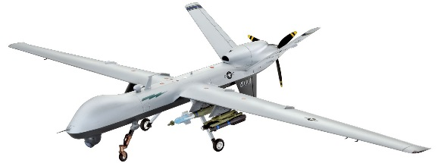](https://www.google.ch/url?sa=i&rct=j&q=&esrc=s&source=images&cd=&cad=rja&uact=8&ved=0ahUKEwjThpXJ_P7LAhXCcBoKHeGnCB8QjRwIBw&url=https%3A%2F%2Fwww.haertle.de%2FPlastikmodellbau%2FFlugzeug%2BBausaetze%2FRevell%2B04865%2BMQ%2B9%2BReaper%2BDrohne%2BBausatz%2B1%2B48.html&bvm=bv.119028448,d.d2s&psig=AFQjCNFsy5dqdhEcPVOACLevvnw63GQ0eQ&ust=1460202550279063)

Klasse:________ Name:________________